Class_____________________ Date_____________________ Time______________________

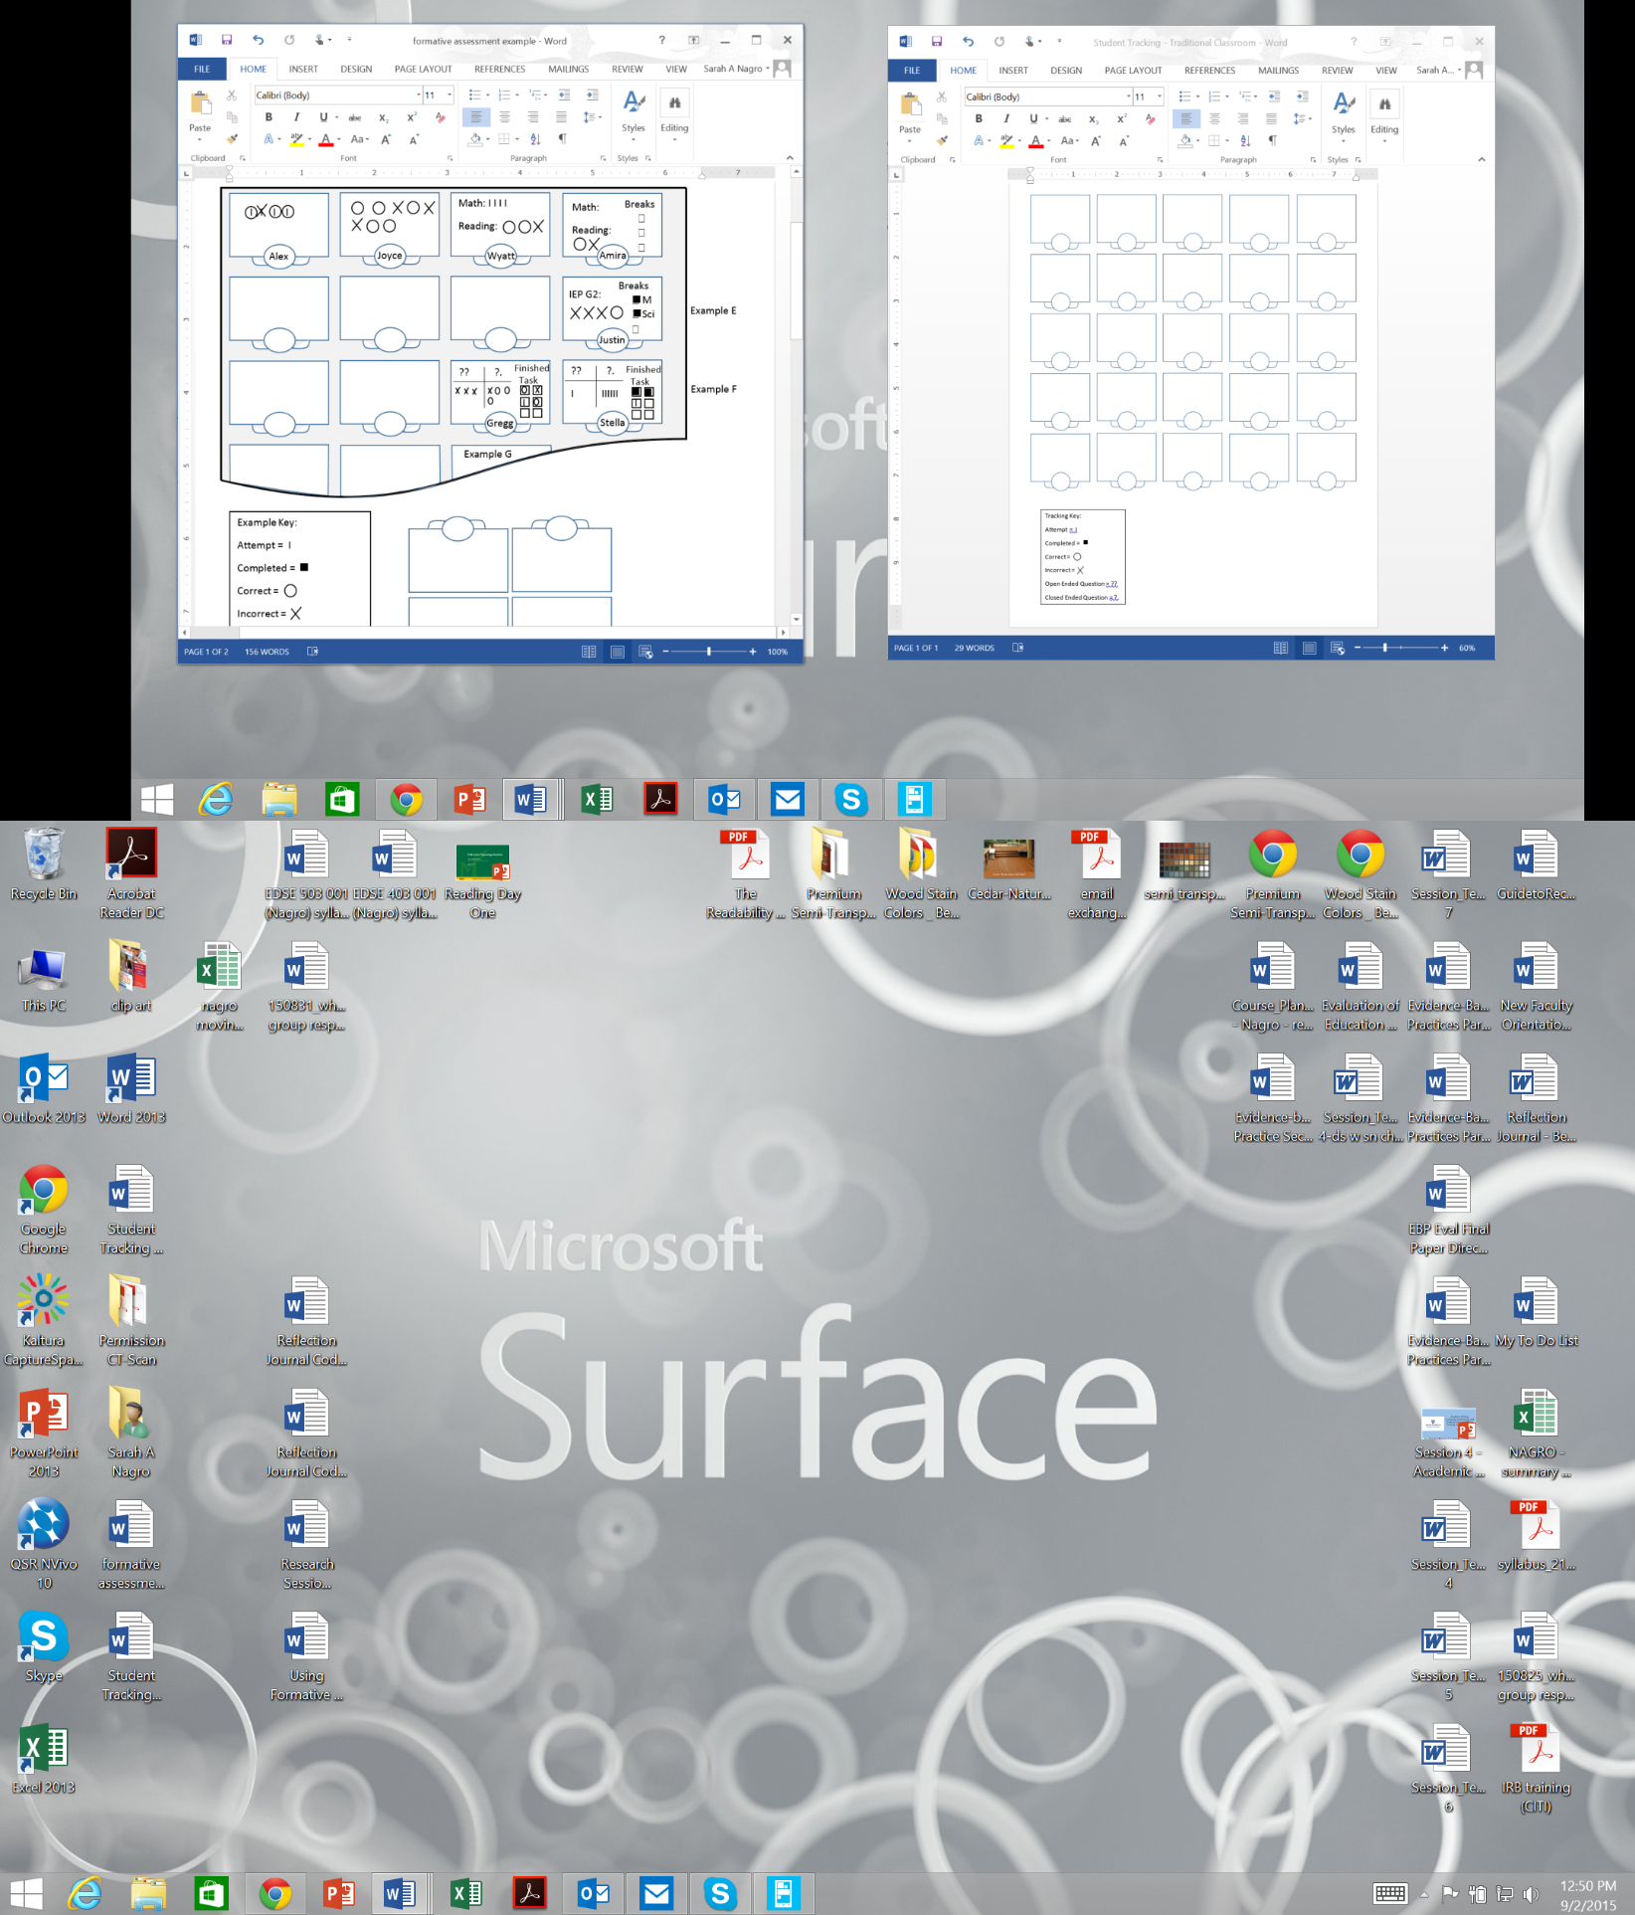

Examples:

Tracking Key:

Attempt = I

Completed = 

Correct =

Incorrect =

Open Ended = ??

Closed Ended = ?.